Newsletter

U3A Calpe March 2011 2222011022220112011


Postal address: U3A Calpe,Suite 416,Total Post, Calle Corebeta 10,Calpe,03710

Web site: www.u3acalpe.com

Daffodils “that come before the swallow dares, and take the winds of March with beauty.” The Bard

New Members: Welcome to those who joined us at the General meeting on February 10th.
Thanks to Tina, assisted by Janet Bond, for a very enjoyable evening at the Calpe Steak House. Many danced the night away!
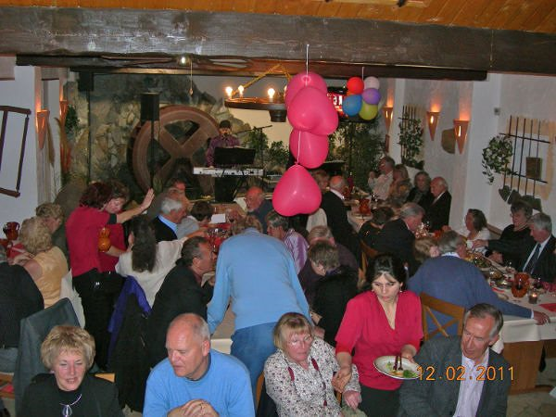

Forthcoming events

Join a trip to Alicante which includes lunch, shopping and guided tours at a bargain price of
35 euros. Pick up at 9am, El Corte Ingles at 10am, before, by bus, going for a guided tour of the Castle & the Marq museum. After lunch, drinks inc.,visit the Old town, by bus, leaving free time until meeting the bus for the return journey at 7pm.

U3A daytrip to Valencia, on March 17th the flowers will be beautifully prepared for the festival.
Call at the Travel desk..
Cirque du Soleil are coming to Alicante on Sunday August the 14th
We can join with Moraira U3A to make up a group which will include coach travel and cost 65 euros per person. If numbers are not enough perhaps people can help with cars, “tickets only” cost 55 euros. It will be block booked very quickly, put your name down now at the travel desk.

HMS PINAFORE will be performed by the Gilbert & Sullivan Society at the Casa Cultura onThursday March the 31st & FRIDAY, April 1st., both performances starting at 8pm. Tickets 12euros, but to a U3A group booking 10 euros.
Book now, it is a very popular operetta! Tickets available at the General Meeting.

The Charity Shop of Calpe are holding a fashion show and make-up demonstration by Avon on Wednesday, March 16th. at El Bolero starting at 2.30 pm. Tickets are 5 euros(inc.a drink) and can be obtained at the shop or by ringing 96583 3454. See you there!

U3A at Easter. Help us to celebrate after the General Meeting on April the 14th.
People who bake, please bring either a plate of iced cupcakes or hotcross buns, others bring a plate of cakes, e.g. magdalenas with a little chocolate or icing on top, or muffins, little eggs or jelly beans. These should go down well with a taste of wine For 1 euro you may win a large Easter Egg. If you are really a fun person wear an Easter Bonnet, smart or funny, and win 1 of 3 prizes.

Festivities.
If you are wanting an excuse to have fun, St.Patrick’s Day is on March the 17th, Mothers Day on April the 3^{rd.}.
Easter is a much feted festival in Spain. Palm Sunday sees a spectacular procession in Elche which produces most of the palm branches for worldwide celebrations.
A little further afield, Lorca holds a marvelous Easter street procession, taking its inspiration from Roman times. Chariots are driven down the main street which is lined on either side with tiered seats filled with cheering crowds waving white squares..The large, modern Centro de Visitantes were most helpful, in English too. Easter is late this year, April 22/24

The Ladies Luncheon Club.
This was started just 3 years ago and has proved a popular addition to the activities section of the Calpe U3A. But it is the title which confuses. It is nothing to do, with gulping down from massive jugs. It is something I stole from the Ladies Section of the Javea Golf Club. They have a section called Just Us Girls, JUGS. I did apologise at the time but doubt they have a lien on the name. It was most appropriate for us.
To turn to practical matters. There is no membership other than membership of the U3A Calpe, so we have a moving population. Any lady member is welcome to come and join us. During the winter we meet for lunch every 4 or 5 weeks, at different restaurants in Calpe, not returning to any who do not give good service. Quite occasionally we have a speaker. There are mixed feelings ab out speakers: if they are good thet are “wonderful”, if not “why do we want one?” The trouble is you do not know in advance. One of the best, Pauline Goff of local radio fame, was cut short by appallingly slow service from that “restaurant of the month”. That restaurant will not get a return visit from us but Pauline might. It is normal to provide a meal for the speaker and a trifling gift to say thank you. We do have a Treasurer who does more than look after the payments. She is in this case Angela Baumgarten.

You can book at the next General Meeting, or call me on 96583 2623 Jean Lakin

Men`s dining.
The meal at Meijas 3 on the 24th. of February was much enjoyed. We can certainly recommend the Meijas restaurants to newcomers. They serve good, fresh, honest food . There’s a wide choice in 3 courses with a menu del dia, which includes a drink, for 8. 50 euros. No hanging about, either. Speak to Roger Milsom (96574 8827) if you would like to hear about the next meet.

Judi Hiorns works at the top of the town charity shop(in the arcade just before Bijou Brigitte, on Miro) She welcomes any used birthday cards to pass on to the Jalon Valley Help group, opened and hardly used toiletries for Battered Wives, and stamps to sell to raise funds for the shop. A great opportunity for recycling. The shop receives and sells your reusable clothes and bric a brac and is open on weekdays from 10.00 to 1.00. On Saturdays it’s been successful opening from 10.30 to 1.30. Several U3A members are sure to welcome you and chat whilst you are looking out for that certain something.

TIPS FOR THE ‘LAID-BACK’ GARDENER

- Look around at the plants which thrive on neglect in your neighbourhood.Learn to love succulents, mediterrenean herbs and shrubs, and native trees. Don’t forget that lots of the exotic tender plants, which had to be dug up/carefully nurtured through winters in England,[e.g. Cannas, Dahlias,Osteospermums,] are perfectly hardy, and can be left in situ, here in Spain.
- Following on from the above,don’t be too hasty or rigourous about weeding, and let ‘serendipity’ play a part. Cistus,wild Gladioli,bright blue Pimpernels and other ‘goodies’ may make their way onto your plot. If you don’t like them where they land,turn some old builder’s rubble, rocks etc. into a ‘scree slope’ and have a wild-flower alpine garden.
- Use the ‘no dig’ method. Spread some worm-compost on your vegetable garden/flower-beds, then put your own compost on top. The worms will pull it underground for you,without destroying the roots of existing plants. Dig only when planting new trees/shrubs etc.,and then add compost at the same time.
- Aim for the ‘English country garden’ or even[if you have a large plot,] the latest ‘Prairie’ look. Don’t be too swift with the shears and secateurs, let plants seed themselves around, and spread out, and cover as much ground as you can with plants. This will protect the bare soil from the sun,stop clay soils from cracking, and ripping your plants roots apart, and lessen the need for watering the garden.
- If you live in a pine-tree area avoid gravel mulches. The pine-needles will soon destroy its pristine appearance,and you will spend fruitless hours trying , in vain, to remove them. Much better to settle for a pine-needle mulch instead[and the pine-cones also make an attractive mulch around the base of trees and shrubs.]
- Save time, effort and money,and earn ‘brownie points’ at the same time, by being ecologically aware. Have a compost bin for garden waste/vegetable peelings etc. Put fallen leaves/clippings into bin-bags in a hidden part of the garden, and leave them for a year or two.Invest in a garden-shredder to turn woody waste into mulch. Then you won’t have to struggle up to the nearest garden waste collection point, or back from the garden-centre with bag fulls of compost .etc.You can also feel quietly superior about not destroying the peat forests or contributing to global warming,by importing compost from 3rd world countries!
- Keeping on with the ‘ecology ‘ theme, avoid using sprays/chemicals/slug pellets etc. Encourage birds and ‘good’ insects like Praying Mantis,and try to tolerate the rest. Or , if you must destroy, squashing greenfly/aphids, and stamping on caterpillars and slugs is a much quicker, more humane method, than poisoning them slowly with chemicals[and also take less of your valuable time.]
- Learn the value of ‘serendipity’, and learn to recognize the seedlings of plants that you want to keep. E.g. in the vegetable, or flower garden, let 1 or 2 plants go to seed, and you will never need to sow them again. Somehow these self-seeded lettuce, spinach-beet, sweet-peas and osteospermum are always stronger, earlier and more successful than the rows of seeds that you lovingly sow and tend yourself!
- And finally, make sure that you have plenty of seating areas in your garden. So that, with all the time you’ve saved, by being a ‘laid-back’ gardener you can sit back, look, listen, smell, - and really enjoy your garden.
JoyLally

Diary date!
Next meeting of the Costa Blanca Northern Gardening Circle is , as usual, on the first Wednesday of the month, that is April 6th. at la Senieta in Moraira at 2.00 for 2.30pm. The topic will be “Citrus fruits” and there will be a question and answer section and the usual raffle with plant prizes. Hope to meet you there, Joy (96649 8681).

Tip from Pat Spencer:
Look on the Help of Denia website for details , you will soon have to use an interpreter when you visit a doctor, the Valencian Doctors state.
I have details of 2 interpreters if you care to contact me on 96583 4586

Sorry you’re leaving ,but do come back to visit us soon.

Many happy members of Mosaics came together to bid aurevoir to Jo and Tom Archer. They enjoyed a tasty meal together at the Aquaramarine restaurant before Jo & Tom left fon their search for a new home in North Devon.

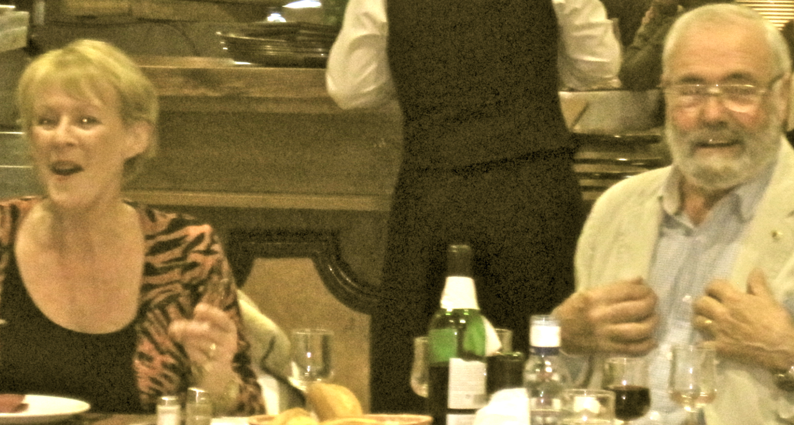

Thank you both for sharing with us your many talents , your home and your sense of fun. You helped make the last Exhibition of Work a great success.
Don’t leave it too long before you come back to see us.

LOOSE ENDS
Peter Hardcastle is starting a new group, Loose Ends, a club for members who actually find time on their hands. Maybe you are single or your partner is absent for a while.
Members will meet at Spasso on the Levante beach on Tuesdays between 2p.m. & 4p.m. starting on March 15th. If you feel you need to break the ice wear your U3A badge or carry a FREEPOST to be recognised.
The bar has free Internet so you can use your computer skype if you wish. Come along on March 15th and help make this new venture a success. Please do not be at a loose end. Peter Hardcastle

Keith Wildman of AFPO
What an interesting talk he gave at the February meeting. In a clear and pleasant style he showed us how diligently they pursue what for the members involved are awful problems.These are not that unusual to encounter in Spain and need expert legal advice which is not from within Calpe. It sounds well worth joining for 15 euros per household.

The Banquet with friends.

On February the 13th. some 65 0f us thoroughly enjoyed our firtst social event of the yearat the Calpe Steakhouse. The food was splendid and plentiful and the restaurant went out of its way to ensure that everything was as we had wished. We were entertained throughout by an excellent duo who played music that those of a “certain age” remembered from our youth. The more energetic of us danced while others simply enjoyed who sang the originals. Thanks have to go to Tina Wallis and Janet Bond for arranging it.

Let’s hear from you now with tips, news, trips you have been on and what you have discovered! Enid on 96583 7554

