Newsletter

U3A Calpe APRIL 2011 2222011022220112011


Postal address: U3A Calpe,Suite 416,Total Post, Calle Corebeta 10,Calpe,03710

Web site: www.u3acalpe.com

New Members. Welcome to 19 new members who joined us at the March meeting.

Thanks to Sandy Bianco for 0rganising the red star group, Zumba Dancing with the Morara/Teulada U3A.
It suits all ages and takes place at La Sieneta, the new white building near the olive tree roundabout, near the Friday Market in Moraira. Give it a try on Mondays at 4 p.m., cost 4 euros.

Congratulations to the Gilbert & Sullivan Society whose lively performance gave such pleasure and to the tenor, who came to their rescue.

Forthcoming events: 

The speaker at the April meeting was Mrs. Chris Duffin , formerly a governer of a UK prison. In May her husband, Harry will give another fascinating talk, see the May Newsletter for further details.
.
A weekend in Madrid from May 3rd to 5th go to the Travel Desk at the General Meeting to book for this super deal..
“Cabbages & Kings” an exciting demonstration by U.K. National/ International Flower arranger, Angela Hyde in the Salon de Actos Espai Senieta, Moraira, April 14th..Doors open at 2.15…… ring Tina for more information.

Meeting of the Costa Blanca Gardening Club on May 4th at the Salon de La Senieta. Ring Joy on 96649 8681

Javea invite you to their annual May Ball on May 6th.Tickets, including a meal, are 35 euros. Entertainment is by Abba Elite..

The Moraira Chess group invite our members to join their group on Thursday mornings at La Senieta. Contact Jan Luxton on 96649 8143

From time to time the Moraira Art Group organize free lectures at La Senieta . They have just held one on Van Gough, there will be more to come at La Senieta, the new white building on the olive round- about near the Friday market carpark. Watch this space. Sandy Bianco.

TRAVEL: FUTURE TRIPS
CONTACT JOHN or TERESSA on 96 583 490
MADRID CITY VISIT & STAY 3rd,4 & 5th of May: 3days (2nights) including time out to visit Aranjuez & Lagunas of Ruidera, luxury coach 4star hotel half board includes wine & water, Cost 225 Euros p.p. Madrid is Spain’s capital city with all its splendour & history & is one of the best capitals in Europe.to visit.
N.B.It cost us, 2 pensioners travelling by rail from Alicante, 380 euros staying only 2 nights. Congatulations, John, this is an excellent offer in a 4-star hotel half board plus a trip. We loved Madrid. Editor
Royal Caribbean Cruise trip now closed for further booking due to the cruise company increasing its prices, those who booked early can content them themselves knowing they have booked at the lowest possible price.
Hoya De Cadenas Winery, visit 23rd of September, situated just north east of Valencia is a day trip that includes coach from Calpe ,lunch including wine, a tour by train through the vineyards and a stop to see the making/blending processes. . Price 35 Euros p.p.
THE WHITE VILLAGES ROUTE, 3rd Oct 6 days 5 nights by luxury coach, hotel 3 and 4 star half board, wine & water included with meals, includes a guide to accompany us, boat trip, price 275 Euros p.p.. Includes San Lucar De Barrameda, Cadiz- Puerto De Santa Maria, Jerez De La Frontera, Vejar De Frontera- Gibralter, Arcos De La Frontera, Antequera & home to Calpe: Single supplement 19 Euros.
FAR EAST TOUR/CRUISE: 16 Days: departing 2nd Feb 2012 International flights Heathrow/Singapore and Hong Kong/Heathrow by BA. Includes Cruise ship FUNCHAL for 11 days: Day 1 fly to Singapore days 2 & 3 in Singapore, Day 4 embark by cruise ship “FUNCHAL” for 10 day cruise, day 5 cruising at Sea, day 6 Kuching Malaysia , day 7 cruising at sea, Day 8 Maura, Brunei, Day 9 Kota Kinabalu Malaysia, day 10 cruising at sea, days 11 & 12 Manila, Philippines, day 13 at sea days 14,15 & 16 Hong Kong then later of the 16th transfer to airport for the flight back home. The “FUNCHAL” is a classic cruise liner with a fascinating and proud maritime past, having served as a Portuguese Presidential Yacht, it has recently undergone an extensive $12m refurbishment & refit, increasing cabin size & refreshing soft furnishings, facilitates aboard include 2 restaurants and 5 bars, a library & card room, swimming pool, shop, gym & hairdressing salon.
Final price for this trip is still to be finalised depending on the number of members who want to book and the type of cabins they require…..Stop press prices now available from the travel desk.
What do you know? A short quiz to sharpen your wits.( answers on page 4.)

- In which sport would you see an eskimo roll?

- Which Barcelona player won “Footballer of the Year 2 years running 2010/ 2011?
- Which outspoken tennis player/commentator said “My greatest strength is that I have no weaknesses”?
4 In which year did the Olympic games take place in Barcelona?
5 In which decade did Roger Bannister run the first under 4 minute mile?
Those ladies who belong to MOFTAG will recognise these as they are taken from a much longer quiz at a recent meeting. The 2nd Wednesday of the month they meet for a drink and a speaker for example and to keep up to date with the various trips, meals or holidays in between. Why don’t you go along to the General meeting at the Metro café , at 2.30 p.m. on the second Wednesday of the month?I’m sure you will find friends. You will also find them outside the Delphin pub in a street left of Miro going uphill(not far up)on May 14th when they hold their fete to raise funds for the charities they support. There will be homemade goodies & bric a brac.

How can you contribute to the Newsletter? .
Send in a quiz or tip or interesting comments, a photo taken on April 29th (call 96583 7554).
VALENCIA
John Pickford enjoyed the ladies in their national dress (see Bob Bambers photos 0n page 3) the bandstand, the general air of excitement countered when, unexpectedly, fireworks exploded intermittently.
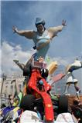
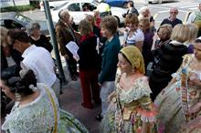
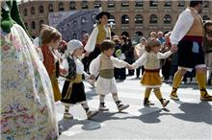

Apart from a visit to Oceanographic I had never been to Valencia, so I was filled with excitement as we set of on a sunny morning for a visit to the city.
My target was the preparations for the Fallas celebrations on the 19th. Having dropped off the people visiting Oceanographic and the shopping centre and nearing our destination the journey started to become both interesting and frustrating. Aiming for somewhere near the Bull Ring as we reached a turning it was closed by the Police keeping traffic away from the processions. We finally came to a long dual carriageway leading away from the Bull Ring. It was lined solidly with coaches. Every time we found a gap the Police moved us on. At one of the junctions our driver managed to do a “U” turn and at last we managed to park in Gran Via de Fernando.
As we walked back in the direction of the Bull Ring the explanation for the large number of coaches became apparent; they we loaded with people making their way to the start of the many processions. It was a bit like walking down Oxford Street when the sales are on. As we made our way along the road, or to me more accurate, as we were taken in the flow, It reminded me of the advice Hagrid gave Harry Potter in “The Chamber of Secrets” “Follow the Spiders”, only in our case it was not spiders but people.
As we followed the mass of people heading towards the bull ring more and more processions started to appear. We stopped for a quick bite to eat and drink before making our way to the Plaza de I’Ajuntament for the start of the fireworks. We got to a point where it became impossible to fight our way through so decided to cut through some side streets, but not before we had witnessed traffic control not for cars but for the processions merging on their way to the dais. We finally found ourselves a good vantage point opposite the main statue and waited for the start.
By the end of a fantastic display where we were deafened and bombarded with the shockwaves from the exploding rockets, smoke filled the complete area. As we started to make our way back to the coach we had chance to admire more of the magnificent statues that littered the city. Bob Bamber.
Friday 15th. April Craft Workshop

Liz Lodge will help you to make a man card(mini half

shirt) and lady’s card(window). She will provide the

materials(bring your craft tray) . 5 euros is payable at the

General Meeting, April 14th. or in box 117,Total Post, Calpe.

For a lift arrange to meet by the dual carriageway, opposite the Marivo restaurant at 9.45 a.m.

96587 4799
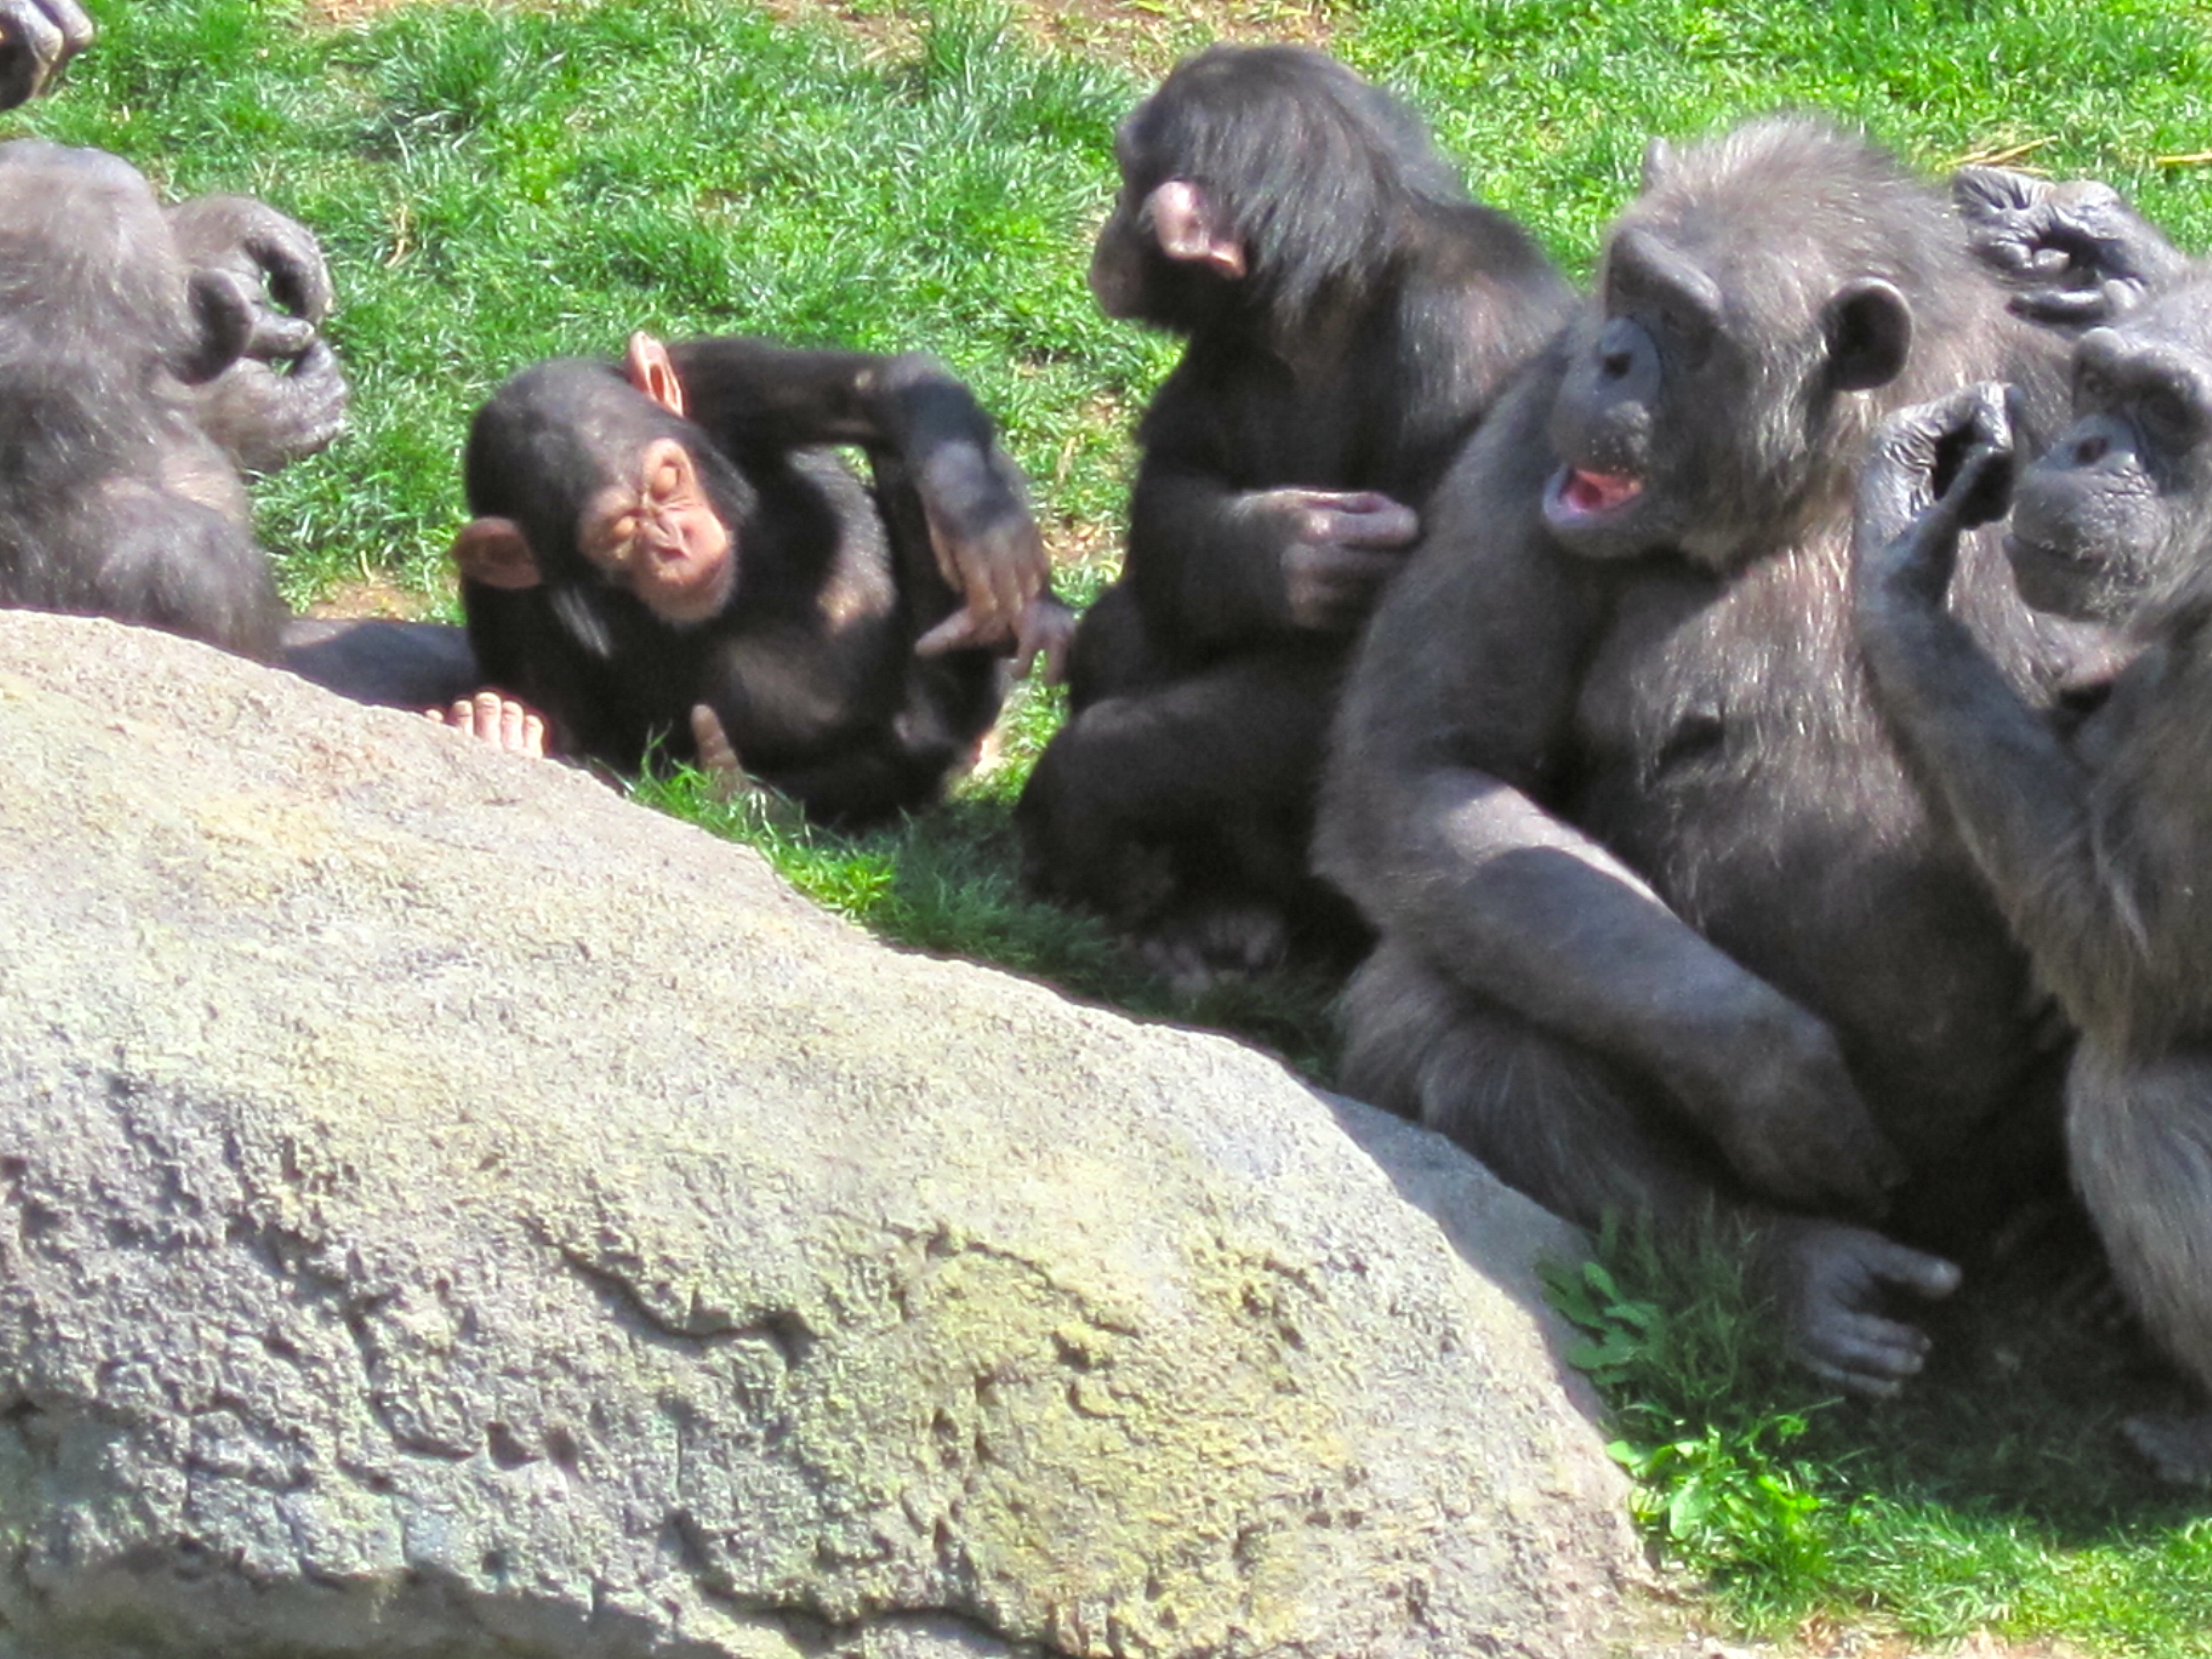
Beverly enjoyed this meeting at the zoo.
 A tip from Beverley: Enquire at the Casa Cultura, free tuition & use of a computer are available !

 Be a computer buddy, pass on information about the U3A to someone you know who does not have access to a computer.

Philosophy Group.

We are a small group, with 8 to 12 members at meetings. We meet at the Galeta Mar Hotel, at 3.pm on the last Saturday of the month. The actual leader had to go back to England for several months so I am filling his place meanwhile.I try to present some aspect of Philosophy that can usefully be applicable to modern life and thought, together with the comments of various philosophers from ancient to modern times. I am not a teacher of philosophy as such, but like to present it in a way that enables members to express their own opinions, and we sometimes have quite lively discussions.
Last year I presented a three part look at Creation and the Cosmos,Evolution,Science and Religion which was much appreciated.
On Saturday 26th our subject was the first part of Wisdom and Knowledge; what the Philosophers themselves tell us about it; how to acquire it and how to recognise it. Part 2 will be at the same place and time on Saturday, April 30th. Anyone who feels they would like to join us for this session would be very welcome. We usually order drinks or coffee from the bar to help things along.The venue is excellent, very comfortable.
Peter F. Purvey 96583 4139

Hot news from the Table Tennis Group.

Tuesday 22nd March saw the first of what I hope will be an annual Table Tennis match between Calpe U3A and Val de Pop U3A. Eight players from each team played a total of sixteen doubles games.
It was a tight run match right up to the last three games when the home team, Calpe, managed to nick it. The match was followed by tapas and wine for the visitors and all members of the Table Tennis group. Most enjoyable.
Keith Cherry Well done all!

Quiz Answers.

5.In the 50s 4.199 3.McEnroe 2.Messi 1. Kayaking

Stop press ! 8p.m. on the 10th of May
Javea Players Latest production will be the brilliant comedy “Quartet” by Sir Ronald Harwood, directed by Sybil Kent. Four retired opera singers living in a retirement home for artistes and their efforts to recapture their former glory. This comedy will be a Gala Production on the re-opening of the Studio after extensive refurbishment(comfortable new seating,a modern bar/lounge area toilets with wheelchair access).

Tickets(inc. coach) 15 euros at the Travel Desk, at travel@u3acalpe.com or by telephone, 96583 4904.

A little bird says it’s to be made into a star-studded film soon, but you will be able to say you saw it with the Javea Players!

U3A Summer Picnic June 16th. 

Join in the fun at the professionally catered for Summer picnic.
Venue: Ermita La Cometa III , Calpe.
Hot and cold buffet inc. alioli & bread and a dessert @15 euros.
Please bring your own drinks
Book at the General Meeting with a 5 euro non returnable deposit, or contact
Janet Bond on 96574 8665

